­­Triibe

**Radwan Susan**

**Zaid Al-Tamari**

**Omar Thaer**

**Doaa Abd Aljbar**

**Hamza Khatari**

**BACHELOR'S DEGREE**

**INFORMATION TECHNOLOGY**

AL-HUSSEIN BIN TALAL UNIVERSITY

2022

**(CERTIFICATION OF PROJECT)**

Permission to Use

In presenting this project in fulfillment of the requirements for a degree of  
Bachelor of Information Technology from Al-Hussein Bin Talal University agrees that the University Library may make it freely available for inspection. We further agree that permission for the copying of this project in any manner, in whole or in part, for the scholarly purpose may be granted by my supervisor(s) or, in their absence, by the College of Information Technology. It is understood that any copying or publication or use of this project or parts thereof for financial gain shall not be allowed without my written permission. It is also understood that due recognition shall be given to me and Al-Hussein Bin Talal University for any scholarly use made of any material from my project.

Requests for permission to copy or to make other use of materials in this project, in whole or in part, should be addressed to:

College of Information Technology

Al-Hussein Bin Talal University

Ma’an, Jordan

Abstract

In recent years, there has been a significant increase in the number of social networking sites (SNSs), which some have referred to as an emerging phenomenon. Aside from SNSs' primary role of communication, the applications embedded inside them are extremely popular and help to assist in attracting new users.

Triibe is a website with a modern approach to social networking. The project's primary purpose is to generate and reflect social interactions between people through a web-based online service, platform, or site. The project comprises network services that will provide a unique blend of outstanding features for many social networking websites, as well as functionality not seen on other websites. Each procedure is divided into separate modules. All software-related data is stored in a single, centralized database, and each module is linked to the next.

Users will be able to log in once the system has been implemented. They will have access to a variety of features, including sending messages, creating posts, sharing files, and many others.

Finally, we believe that a network of websites that consumers visit regularly could provide the functionality of an Internet-connected environment.

Acknowledgment

Table of Contents

Permission to Use i

Abstract ii

Acknowledgment iii

Table of Contents iv

List of Tables viii

List of Figures ix

List of Appendices x

Glossary of Terms xi

List of Abbreviations xii

CHAPTER 1 Introduction 1

1.1 Project Background 2

1.2 Problem Statement 3

1.3 Project Objectives 4

1.4 Project Significance 4

1.5 Project Gantt Chart 6

CHAPTER 2 LITERATURE REVIEW 8

2.1 Definitions 8

2.2 Advantages of social network 8

2.3 Disadvantage of social network 9

2.4 Social networks in learning environments 9

2.4.1 Facebook 10

2.4.2 Twitter 10

2.4.3 Instagram 11

2.5 Tables 12

2.6 Figures 13

CHAPTER 3 Methodology 14

3.1 The Software Development Life Cycle (Waterfall) 14

3.1.1 Requirements 15

3.1.2 Design 15

3.1.3 Implementation 16

3.1.4 Verification and testing 16

3.1.5 Deployment and maintenance 16

3.2 Advantages of the Waterfall methodology 16

3.3 Disadvantages of the Waterfall methodology 17

CHAPTER 4 ANALYSIS AND DESIGN 18

4.1 Analysis 18

4.1.1 Triibe from the technical point of view 18

4.1.2 Triibe from a risky point of view 18

4.1.3 Triibe from an economical point of view 19

4.1.4 Triibe from a SWOT point of view 19

4.1.5 Triibe from a Managerial point of view 21

4.1.6 Requirements Determination 22

4.1.6.1 functional requirements 22

4.1.6.2 Non-functional requirements: 23

4.1.7 System's Requirements 24

4.2 Design 24

4.2.1 Logical Design 24

4.2.1.1 Use Case Diagram 24

4.2.1.2 Admin use case diagram 29

4.2.1.3 Sequence Diagram 30

4.2.1.4 Context diagram 31

4.2.1.5 Level 0 Data Flow Diagram 31

4.2.1.6 Entity Relationship Diagram 34

4.2.1.7 Database schema: 35

4.2.2 Physical Design 36

CHAPTER 5 findingS 37

5.1 Introduction 37

5.2 Languages and Platforms 37

5.2.1 Programming Languages 37

5.2.1.1 HTML 37

5.2.1.2 CSS 38

5.2.1.3 JavaScript 38

5.2.1.4 jQuery (AJAX) 38

5.2.1.5 PHP 38

5.2.1.6 MySQL 38

5.2.2 Compilers & Editors 39

5.2.2.1 Visual Studio Code 39

5.2.2.2 PHP My-Admin 39

5.2.3 Tools 40

5.2.3.1 Figma 40

5.2.3.2 Diagrams.net 40

5.3 Project Interfaces and their Description 40

5.3.1 Descriptions of the interfaces 41

5.3.1.1 Sign-In page 41

5.3.1.2 Sign-Up page 42

5.3.1.3 Home page 43

5.3.1.3.1 The Navbar 43

5.3.1.3.2 The friend’s sidebar 44

5.3.1.3.3 The right sidebar 45

5.3.1.3.4 The posts area 46

5.3.1.3.5 Write post 47

5.3.1.3.6 Home page (Dark mode) 48

5.3.1.4 Personal profile 49

CHAPTER 6 OBSERVE AND EVALUATE 50

6.1 Testing Methods 51

6.1.1 Functional Testing 51

6.1.2 Debugging Testing 51

6.1.3 Bottom-up Testing 51

6.2 Data validation 52

CHAPTER 7 CONCLUSION 53

7.1 Conclusion 53

7.2 Limitations 53

7.3 Future Works 53

references 54

List of Tables

Table 2.1: Comparison between different social media platforms 12

Table 4.2: H/W. S/W Specifications 36

List of Figures

Figure 1.1: Project Gantt Chart (Tasks) 6

Figure 1.2: Project Gantt Chart (Chart) 7

Figure 2.1: Identification on the internet and through social media 13

List of Appendices

Appendix A Sample Appendix 54

Glossary of Terms

<Delete if not applicable>

List of Abbreviations

<Delete if not applicable>

# Introduction

In the twenty-first century, individuals communicate through social networking. Individuals are divided into specific groups through social networking, such as small communities or local subdivisions. Social networking may also occur in person, especially at work, at colleges, and in high schools, but it is most commonly online. This is because, unlike most high schools, universities, and workplaces, the internet is home to millions of individuals looking to meet new people.

The mapping and measurement of interactions and flows between individuals, groups, organizations, computers, URLs, and other related information and knowledge entities constitutes a social network. People and groups form the network's nodes, while the links represent interactions or flows between them. The social network analyzes human interactions in both a visual and quantitative way.

The social networking website project is a large undertaking that includes features such as profile updating, friend list organizing, and a variety of additional applications to improve the website's overall appearance and feel. However, we are focusing on three key aspects or modules in this project: group and community pages, and profile management.

The group's module allows individuals to create and join groups of like-minded people and hobbies, as well as identify which members share mutual interests that might benefit one another.

The purpose of community pages is to bring people together around a common interest. It allows people to learn about a topic and share their opinions and ideas about it.

The profile management module keeps track of a user's information, such as name, likes, dislikes, interests, status, etc.

On social networking sites, profiles and friend lists are two important elements. The final feature is public commentary. Individuals can leave comments on their friends' profiles using this function. These remarks are publicly published and available to everyone with access to that profile.

## Project Background

Social networking sites (SNSs) like Facebook, WhatsApp, and Instagram have drawn millions of users since their launches, with many of them incorporating them into their daily routines. Approximately 2 billion active users are currently browsing these websites daily.

Students now do not have time to share with their classmates. As a result, universities require a method for effectively distributing messages and connecting with others. People, on the other hand, want everyone to know about them and want to expand their network.

There are several techniques to gain recognition, but they all require a large sum of money to be effective. On the other hand, social networking is one of the most cost-effective strategies to get recognition. If we consider several scenarios in which individuals demand something that is not given by that application, they must rely on other resources, whether they are urgently necessary. As a result, gathering such resources and putting them to their intended use takes a substantial amount of time under that scenario.

The website will assign a bridge among students to link the student with the entire institution and provide a variety of features to assist him in becoming more productive and successful.

## Problem Statement

People face many issues in their personal and professional lives if social networking services are not available. As we all know, social networking was created to facilitate social communication.

Although recent technology advancements have lowered barriers between individuals, social life among students inside their colleges may be chaotic and confusing.

A study by researchers at the University of Minnesota "found that of the students observed, 94 percent used the Internet, 82 percent went online at home, and 77 percent had a profile on a social networking site." (Staff, 2008).

According to a survey that was conducted by the Whitmore School of Business and Economics and by the University of New Hampshire, they interviewed 1,127 college students. Among these students, 96% use Facebook, 8.4 out of 10 use YouTube, 20% use blogs, 1.4 out of 10 use Twitter, 12% use "Myspace" and 1 out of 10 use LinkedIn. Also, 81% of college students use social sites (oclc.org). These statistics seem to show that many college students often use social networks or social media, but the number of these websites is high enough to make the usage of these websites unorganized and unmanaged, which will leave some students unable to connect with their colleagues and teachers. (Egot, 2017).

Another challenge we face without social networking platforms is a lack of knowledge exchange. If we don't have access to the medium, it's difficult to come up with an idea or express it to others. If we consider ourselves without the social networking site, we can probably think of a few more examples. As a result, it has a significant presence in people's lives.

## Project Objectives

This project's major goal is to create a centralized application that will assist students in promoting themselves inside the university. And the system not only allows for promotion but also allows for the sharing of information and the transfer of data.

A list of the main project objectives:

* Texting with students or teachers.
* Connecting with other students by video call.
* Reach the audience easier and faster with groups.
* Sharing files or pictures or videos with others.
* Sharing your location with other members.
* Reach learning resources easier.
* Get some housing and transportation and study locations guidance.
* Entertainment and having fun.

## Project Significance

Social network sites sometimes give advantages to students inside their universities or among certain institutions outside of colleges, by sharing information and files among the university students, these activities are also considered by teachers who wish to support the college's professional community. and considered by the university president where he can encourage the use of these types of platforms.

With "Triibe," students, teachers, and employees can easily communicate with each other as well as share files, pictures, and videos inside the platform. "Triibe" solves the problem where students must use different social networking sites to communicate and achieve what they were doing, which makes it more efficient and effective for the students. "Triibe" can also help teachers by spreading the word to the students using groups inside the platform.

Students and instructors can also remain in touch with former friends and colleagues by using Triibe.

## Table Description automatically generatedProject Gantt Chart

Figure 1.1: Project Gantt Chart (Tasks)

Figure 1.2: Project Gantt Chart (Chart)

# LITERATURE REVIEW

## Definitions

**Social networks** are virtual environments that allow users to communicate with one another through the Internet in a variety of ways, including sending messages (text, voice messages, photos, or videos) and holding live interactive discussions in a variety of ways (written, audio-visual, or audio and video meetings and conferences). The lectures can also be streamed live from different parts of the world, and there are more than 500 social networking sites on the internet. Social networking platforms, like many other things, have advantages and disadvantages.

**Social media** is a group of Internet-based applications that builds on the ideological and technological foundations of Web 2.0, and that allows the creation and exchange of user-generated content. (Kaplan & Haenlein, 2010)

## Advantages of social network

* Get job opportunities and marketing for professional jobs.
* Establish and maintain social connections.
* Permanent contact with the world and expanding the circle of social relations
* Opening new and great horizons for pioneering ideas i.e. e-marketing.
* Keep up with the news across the world.
* There is no charge for using social media networks.
* People may discuss ideas, publish news, ask questions, and exchange links on social media platforms.

## Disadvantage of social network

* The impact on family relationships.
* An increase in the number of hours spent on social media by an individual may conflict with his or her professional responsibilities.
* Social isolation and the illusion of virtual communication.
* Risks of fraud or identity theft.
* Addiction.
* Malware additions are possible.
* Concerns about private details.

## Social networks in learning environments

Social networks introduce new ways of learning, giving students choice, providing transferrable skills, assisting peer-to-peer learning, enhancing reflective learning, creating a digital identity, and encouraging social interaction are some of the educational aims of adopting SNS. Retention, sociability, collaborative learning, student engagement, sense of control and ownership, problem-solving and sense of success, visibility of created artifacts, and multimedia integration are just a few of the benefits of bringing innovation and excitement into the classroom. students' positive opinions of the educator engaging in SNS activities, as well as overcoming isolation and regional inequalities, were all highlighted.

These technologies are well suited to providing a learner-centered orientation and enabling both formal and informal learning interactions, which are considered critical to modern learning's community and collaborative meaning-making.

### Facebook

According to 2012 research, Facebook is the top-visited and most used website. Where users can create profiles with photos, lists of personal interests, contact information, and other personal information. Users can communicate with friends and other users through private or public messages and a chat feature. They can also create and join interest groups. (Jess, 2012)

Functionality:

* Making requests to friends
* Message a person privately
* Options for liking and commenting
* Alerts and a newsfeed
* The sharing of photographs
* Current Status

Limitations:

* It is not possible to modify the website's skin.
* Spamming.

### Twitter

Twitter is a global information network that keeps you up to date on the latest articles, ideas, points of view, and news on the topics that matter to you. Simply look for the accounts that interest you and join in on the discussions.

Functionality:

* Writing tweets and sharing them with others.
* Retweet feature.
* Following people.
* Scheduled Tweets.

Limitations:

* Posting limits.
* Spamming.
* Offensive Content.

### Instagram

Instagram is a social media app that lets users share photos and videos. Users can also like and comment on other users' posts, send private messages, search for relevant content, and more. Instagram includes a range of filters and editing tools that users can apply to their photos.

Functionality:

* Start a live video and invite others to watch it.
* Start a live video and share it with others.
* Set your profile to private so that only your friends can see and comment on your posts.

Limitations:

* Spamming.

## Tables

|  |  |  |  |  |
| --- | --- | --- | --- | --- |
| Functionalities | Facebook | Twitter | Instagram | Triibe |
| 1. Profile Editor | Checkmark with solid fill | Checkmark with solid fill | Checkmark with solid fill | Checkmark with solid fill |
| 2. Custom Skins | Checkmark with solid fill | Checkmark with solid fill |  | Checkmark with solid fill |
| 3. Photos | Checkmark with solid fill | Checkmark with solid fill | Checkmark with solid fill | Checkmark with solid fill |
| 4. Post Comments | Checkmark with solid fill | Checkmark with solid fill | Checkmark with solid fill | Checkmark with solid fill |
| 5. Friends | Checkmark with solid fill |  | Checkmark with solid fill | Checkmark with solid fill |
| 6. Video | Checkmark with solid fill | Checkmark with solid fill | Checkmark with solid fill | Checkmark with solid fill |
| 7. Weather |  |  |  | Checkmark with solid fill |
| 8. Privacy Settings | Checkmark with solid fill | Checkmark with solid fill | Checkmark with solid fill | Checkmark with solid fill |
| 9. Black Users | Checkmark with solid fill | Checkmark with solid fill | Checkmark with solid fill | Checkmark with solid fill |
| 10. Report Spam | Checkmark with solid fill |  | Checkmark with solid fill | Checkmark with solid fill |
| 11. Report Abuse | Checkmark with solid fill | Checkmark with solid fill | Checkmark with solid fill | Checkmark with solid fill |
| 12. Chat Rooms | Checkmark with solid fill |  |  | Checkmark with solid fill |
| 13. Instant Messaging | Checkmark with solid fill | Checkmark with solid fill | Checkmark with solid fill | Checkmark with solid fill |
| 14. Groups | Checkmark with solid fill |  |  | Checkmark with solid fill |
| 15. Events | Checkmark with solid fill |  |  | Checkmark with solid fill |
| 16. Ad-Free |  | Checkmark with solid fill |  | Checkmark with solid fill |
| 17. Guides |  |  |  | Checkmark with solid fill |

Table 2.1: Comparison between different social media platforms

## Figures

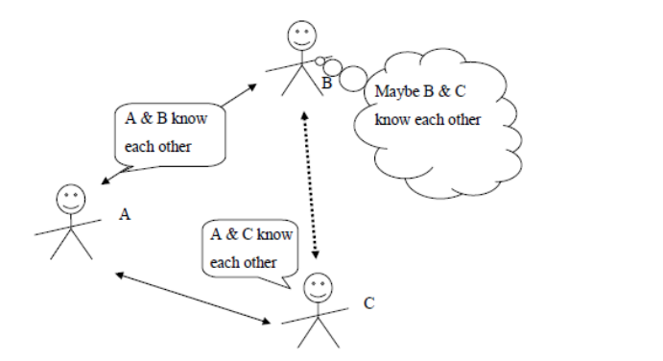

Figure 2.1: Identification on the internet and through social media

# Methodology

The waterfall approach often referred to as the waterfall methodology, is a consecutive development process that flows like a waterfall through all phases of a project, such as analysis, designing, implementation, and validation, with each step completed before moving on to the next.

The waterfall process is supposed to follow the phrase "measure twice, cut once." The waterfall method's success is determined by the quantity and quality of work done on the front end, which includes documenting everything ahead of time, including the user interface, user stories, and all feature changes and outcomes. Because the bulk of the research is done ahead of time, estimations of the time required for each need are more accurate, and the release date may be more predictable. If parameters change along the way, it's more difficult to change direction with a waterfall project than it is with Agile methodology. (Dutta, 2021)

## The Software Development Life Cycle (Waterfall)

Figure 3.1 illustrates the five phases of the waterfall software development life cycle: requirements, design, implementation, verification or testing, deployment, and maintenance.

*Figure 3.1: The waterfall methodology phases*

### Requirements

The waterfall technique assumes that all project requirements can be obtained and understood ahead of time. The project manager makes every effort to fully comprehend the customer's expectations. Documented requirements are used to describe each phase of the project, including expenses, assumptions, threats, roles and responsibilities, performance measures, and completion timelines, and are usually contained in a written document.

### Design

Development teams use scenarios, designs, and analysis tools to create a technological solution to the constraints outlined in the product requirements. First, a higher-level or logical design is established, which specifies the project's objectives and scope, as well as the overall flow of traffic for each element and their interconnection points. After that, it's turned into a physical design with the help of certain hardware and software technologies.

### Implementation

At this level, software developers code programs based on project needs and specifications. They may need to return to the design phase for further consideration if major adjustments are necessary.

### Verification and testing

Testing is required before a product can be delivered to clients to verify that there are no faults or missing functionalities. The project manager's design papers and user case scenarios will be used by the testing team.

### Deployment and maintenance

The maintenance phase begins after the program has been distributed to the market or consumers. As flaws are discovered and client requests for changes are received, a team will be formed to handle maintenance and the delivery of new versions of the program.

## Advantages of the Waterfall methodology

The waterfall technique is a well-defined, uncomplicated project management methodology with a past record. Because the requirements are clearly written out from the start, each contributor knows exactly what needs to be implemented and when it needs to be done, allowing them to properly organize their time throughout the project lifecycle.

The waterfall methodology also has the following advantages:

* During the analysis and design phases, designers can detect design flaws, allowing them to avoid creating flawed code during the implementation phase.
* Once the requirements are determined, the overall cost of the project, as well as the timeline, can be easily calculated.
* Evaluating progress in terms of clearly defined goals is simpler with an organized approach.
* Programmers who join an ongoing project will have no trouble getting up and running because the requirements document should contain all they need to know.
* Clients may not need to add new demands to the project, which causes production delays.

## Disadvantages of the Waterfall methodology

Strengths in one area may indicate shortcomings in another, as in any growth process. Because of the waterfall methodology's focus on upfront project planning and dedication to a certain specified milestone, it is less adaptable and maneuverable later in the project. Changes made later in the process might take a long time, be difficult, and be costly.

The following are some reasons why the Waterfall methodology could not work:

* With this approach, projects might take longer to complete than with an iterative strategy such as the Agile method.
* Clients always add new objectives to projects, which causes production delays.
* Clients sometimes don’t include all the requirements in the design and implementation stages.
* When one part of a process is delayed, it causes all of the others to be delayed as well.

# ANALYSIS AND DESIGN

In the previous chapter, the approach to the project that was used for this one was clearly described. The five phases of the process include requirements, design, implementation, verification and testing, deployment, and maintenance. This chapter will go through these phases in further detail.

## Analysis

The analysis phase defines the results of research and development results and concludes the definition of requirements specification and requirements determination of the project.

**Our project will be analyzed from a different point of views:**

### Triibe from the technical point of view

Triibe is a website that allows the interchange of knowledge, opinions, and knowledge inside universities through virtual communities and networks. Users may connect to the network to make and publish messages, as well as read what other students have posted.

### Triibe from a risky point of view

On our website, when the user tries to write a post, they might enter some inappropriate content that can be unsuitable and harmful for the university in general, as well as spam some meaningless content into the community.

To solve this problem, we will implement some security measures such as limiting the student to one account so they can’t make fake accounts and limiting the student to write a fixed number of posts daily, as well as we will add a list of unsuitable content that will be excluded from the user post automatically.

### Triibe from an economical point of view

Before social media, you had to pay to get information about your company out there. There are substantially fewer barriers to contacting consumers now because everyone and every corporation is their own media brand.

Students may use Triibe to share their thoughts with the community for free.

### Triibe from a SWOT point of view

"A SWOT analysis (alternatively SWOT matrix) is a structured planning method used to evaluate the strengths, weaknesses, opportunities, and threats involved in a project or a business venture

* Strengths: characteristics of the business or project that give it an advantage over others.
* Weaknesses: characteristics that place the business or project at a disadvantage relative to others.
* Opportunities: elements that the project could exploit to its advantage.
* Threats: elements in the environment that could cause trouble for the business or project"

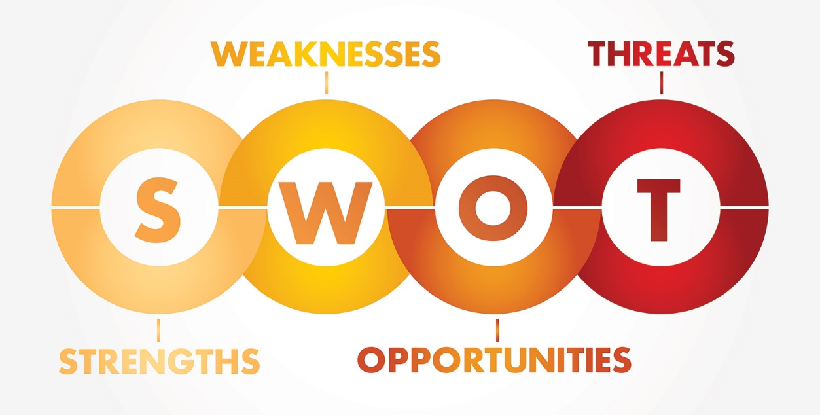

*Figure 4.1: the SWOT analysis’s main components.*

**Strength:**

* There are so few websites focused on the communication between students within the university campus.
* Allows integration with many other websites that help the student.
* The usability is wonderful.
* Recognizes and anticipates the needs and desires of users.

**Weakness:**

* Some functionality, such as video chats and group conversations, is missing.
* Information about users is not well protected.
* A poor image is created by beliefs regarding consumers' privacy.

**Opportunities:**

* The number of people using smart devices to access social media is growing.
* Expansion to other types of learning platforms, such as schools and colleges.

**Threats:**

* Privacy issues like identity theft.
* Social media websites that aren’t limited to a specific facility, such as Facebook and Instagram.
* Some users refuse to use social media platforms and prefer to live an anti-social lifestyle.
* Some users don’t have smart devices to access the platform.

### Triibe from a Managerial point of view

With triibe, the university supervisors can manage the community, by having the access to edit and remove any unwanted content within the website.

As well, teachers can bring their students into groups that can help them communicate more effectively and efficiently.

### Requirements Determination

**What are requirements?**

From a high-level abstract definition of a service or a system constraint to a thorough mathematical functional specification, it can be anything. This is unavoidable because requirements may have two purposes. It may serve as the foundation for a contract bid, so it must be interpretable. As a result, the contract's foundation (if applicable) must be described in full. Both assertions might be referred to as prerequisites.

#### functional requirements

A functional requirement is a definition of behavior between inputs and outputs that are used in software engineering and systems engineering to specify a function of a system or its component.

**Functional requirements of triibe:**

* **Search:** the ability to search for users and groups within the website.
* **Personal account:** the student can log in with a username and a password to control his/her personal account and interact with the pages, groups, and friends that he views.
* **Profile:** the user will be able to see all of his profile information from the different networks on one page divided by tabs.
* **Publishing:**
  + Add your own content.
  + Edit and remove your content
  + Comment, share, and add likes
* **Sharing stories:** A story can be added by the student to his/her account to be seen by the student’s colleagues.
* **Groups and pages:** Allow students to communicate directly with one another and manage pages.
* **Market:** Allow students to sell their products in the community for a profit.

#### Non-functional requirements:

In systems engineering and requirements design, a non-functional requirement is a set of conditions that may be used to evaluate a system's performance rather than specific behaviors. Functional requirements, on the other hand, are detailed descriptions of specific actions or activities. A plan for meeting functional requirements is included in the system design. Because non-functional requirements are usually structurally important, a strategy for meeting them is specified in the system design.

**Non-functional requirements of triibe:**

* **Safety & Security:** The passwords of the users of the website will be encrypted and saved on a decentralized database.
* **Portability:** The system should operate on any OS that has an internet browser and an internet connection.
* **Performance:** The system should operate on low-end computers easily.
* **Maintainability:** The system should be maintained with ease.

### System's Requirements

Our project requires the following:

* Our project requires an internet browser to access the website.
* Our project must be able to work in different environments of operating systems.
* The user must be able to come out of the website at any time he wants.
* Our project requires a stable internet connection.

## Design

Technically, creating a project system follows two fundamental processes: logical and physical design.

### Logical Design

The logical design phase describes all of the functional elements that were chosen for the platform's development without regard to the operating system. This step ensures that the produced system can perform as it should, assuming that it can be implemented on any hardware or system software.

#### Use Case Diagram

**Use case scenario**: User opens the create a new account page where he can enter his information to make an account within the website after that he will have to log in to the website by entering his information inside the log-in page, then he will be able to access several functionalities that the website offers.

*Figure 4.2: Triibe user use case*

**Triibe Actor list:**

* Student: will use most of the functionalities of the website

**Triibe use case list:**

* Registration: The student will input the required information needed to join the website.
* Login: The student will input the required information needed to access the website.
* Search: The student will type a student name or a group name or a page name to access them and join them.
* Add Friends: The student will add a friend to see their posts in your feed.
* Accept / Reject Requests: The student can accept or reject a friend request that has been sent to them.
* Share Posts: The student can share a post with other students or groups or pages.
* Send Messages: The student can send a message to other students to communicate.
* Change Password: The student can change the password of their profile.
* Share Stories: The student can share stories that they have made with their friends.

*Table 4.1: description of each use case*

|  |  |  |  |
| --- | --- | --- | --- |
| Use case name | Actors | Preconditions | Description |
| Registration | Student | Be a university member | The student will enter his info in the appropriate place on the registration page |
| Login | Student | Have an account registered | The student will enter his info in the appropriate place on the login page |
| Search | Student | Be logged in to the home page | The student will search for friends in the search within the home page |
| Add Friends | Student | Have an account registered | The student will add a friend to his friend list within his friend account page |
| Accept / Reject Requests | Student | Have an account registered | The student can accept or reject a friend request that has been sent to them |
| Share Posts | Student | Have an account registered | The student can share posts with their friends on the home page |
| Send Messages | Student | Have an account registered | The student can send a message to other students within the chat tab |
| Change Password | Student | Have an account registered | The student can change the password of their profile within the login page |
| Share Stories | Student | Have an account registered | The student can share stories on the home page |

#### Admin use case diagram

Figure 4.3: *Triibe admin use case diagram*

#### Sequence Diagram

**Sequence diagram scenario**: User opens the create a new account page where he can enter his information to make an account within the website after that he will have to log in to the website by entering his information inside the log-in page, then he will be able to access several functionalities that the website offers.

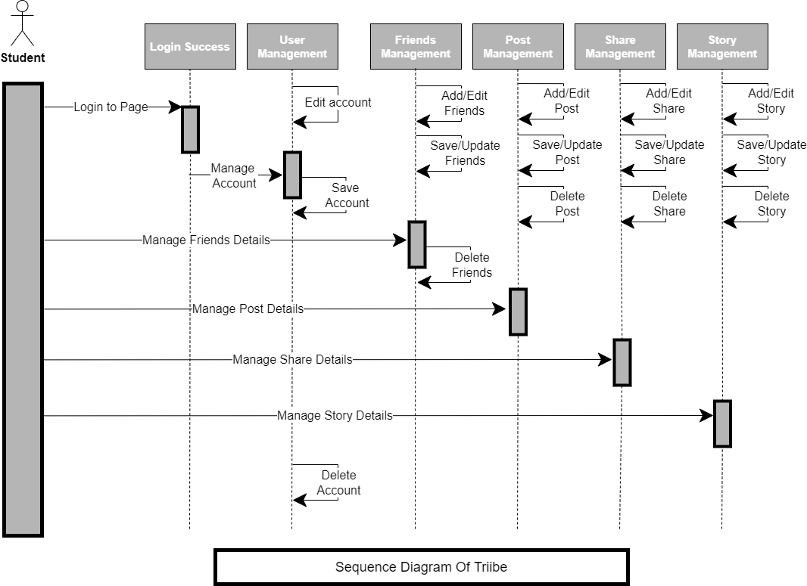

*Figure 4.4: Triibe user sequence diagram*

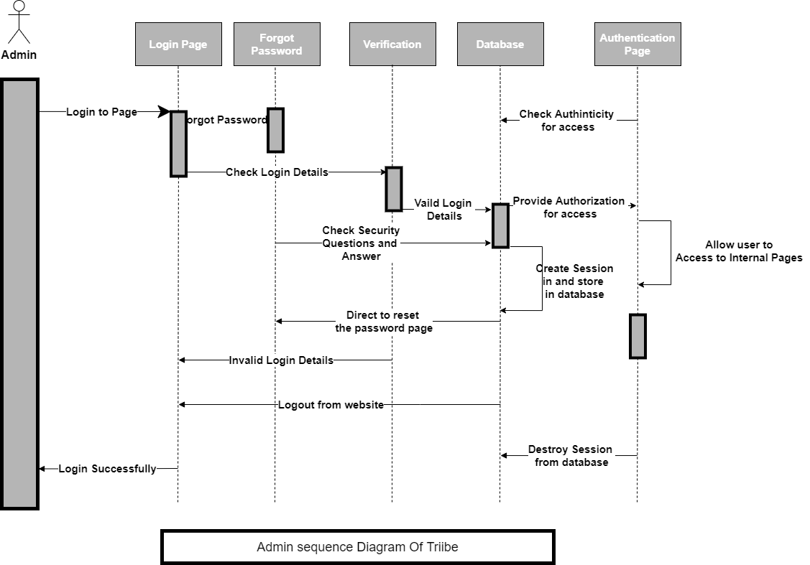

*Figure 4.5: Triibe admin sequence diagram*

#### Context diagram

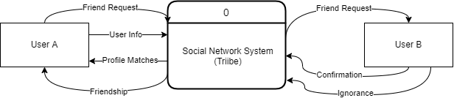

*Figure 4.6: Triibe context diagram for adding a friend*

#### Level 0 Data Flow Diagram

Figure 4.7: *Symbols used in Dataflow Diagrams*

*Figure 4.8: Triibe level 0 data flow diagram*

*Figure 4.9: Triibe level 1 data flow diagram (Log in)*

*Figure 4.10: Triibe level 2 data flow diagram (Home Page)*

#### Entity Relationship Diagram

The ER diagram was created to have a better view of the facts. It was used to deeply understand events, behaviors, and interactions between various entities, as well as to achieve specific requirements.

*Figure 4.11: Triibe ER Diagram*

#### Database schema:

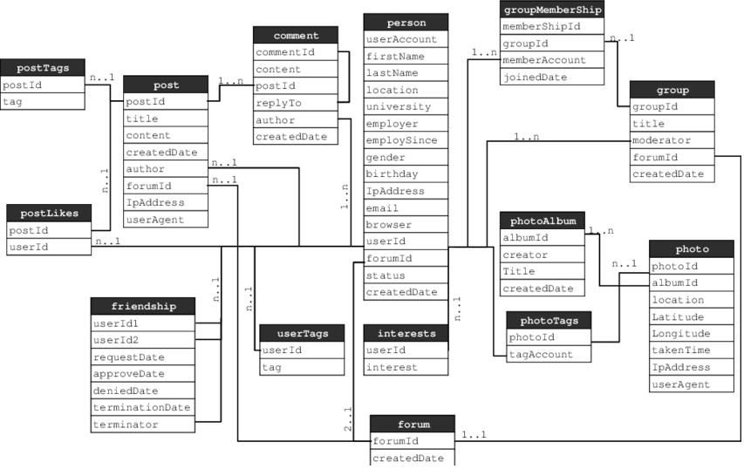

*Figure 4.12: Triibe DB schema*

### Physical Design

Physical design, on the other hand, concerns turning the logical design into a more technical specification for system development. All of the diagrams created in the logical design were converted into structured systems designs while creating the physical elements of the system.

The researcher chose the programming language and database system to be utilized, as well as the hardware platform, operating system, and network environment in which the system would function, during physical design.

Table 4.2 summarizes the specifications.

Table 4.2: H/W. S/W Specifications

|  |  |
| --- | --- |
| Purpose | H/W. S/W Requirements |
| Programming Language | PHP |
| Operating System | Windows 7 & up |
| Hardware | Computers & smartphones |

# findingS

## Introduction

**Implementation:** The process of moving an idea from concept to reality. In business, engineering, and other fields, implementation refers to the building process rather than the design process. (ECTA Center)

Implementation, in the IT sector, refers to the post-sales process of leading a client from purchase to use of software or hardware. This involves the study of requirements, scope, modifications, system integrations, user policies, training, and deployment. A project manager oversees these stages using project management approaches. Business analysts, technical analysts, solutions architects, and project managers are among the specialists involved in software implementations who are relatively new to the knowledge-based industry.

## Languages and Platforms

In the following sections, we will cover the programming languages utilized in the project as well as the applications that assisted us in its completion.

### Programming Languages

#### HTML

You'll need a globally recognized language, a form of publishing native language that all computers can understand, to release material for international dissemination. The Internet's markup language has been HTML.

#### CSS

Any website's style, layout, and display versions for multiple devices and screen sizes are determined using CSS.

#### JavaScript

JavaScript is a scripting or programming language for adding complex functionalities to websites. When a web page does more than simply sit there and show static data for you to look at, when it shows real-time content updates, interactive maps, dynamic graphics, scrolling video jukeboxes, and so on, JavaScript is nearly always utilized. It's the third layer of the standard web technology layer cake, along with HTML and CSS.

#### jQuery (AJAX)

**AJAX (Asynchronous JavaScript and XML)** In short; AJAX is about loading data in the background and displaying it on the webpage, without reloading the whole page (jQuery AJAX Introduction).

#### PHP

The scripting language PHP (Hypertext Preprocessor) is commonly used for creating dynamic Web pages. It blends syntax from languages like C, Java, and Perl. All Web servers support PHP, which stands for "Personal Home Page," often used with the MySQL database.

#### MySQL

MySQL is a relational database management system that can handle massive amounts of information. Our website's MySQL database server provides enormous scalability, allowing our website to handle large amounts of data that must be stored as well as provide us with the reliability and strength to consider our project the main platform for social media within universities.

### Compilers & Editors

#### Visual Studio Code

Visual Studio Code is a Microsoft source-code editor. It's used to make websites, web apps, online services, and mobile apps, among other things. The Microsoft Windows API, Windows Forms, Windows Presentation Foundation, Windows Store, and Microsoft Silverlight are among the Microsoft software development platforms used by Visual Studio. It can generate both native and managed code. Visual Studio comes with a code editor that supports IntelliSense (code completion) and code refactoring. The integrated debugger may be used as both a source-level and a machine-level debugger. Visual Studio Code supports 36 programming languages and allows the code editor and debugger to handle almost any programming language (to variable degrees) if a language-specific service is available. C, C++, C++/CLI, Visual Basic.NET, C #, F #, JavaScript, TypeScript, Extensible Markup Language (XML), Extensible Stylesheet Language (XSLT), HTML, and CSS are among the built-in languages. Plug-ins provide support for other languages such as Python, Ruby, Node.js, and M, among others. Previously, Java (and J#) were supported. (Johnson, Bruce).

#### PHP My-Admin

phpMyAdmin is a free PHP-based program for managing MySQL databases over the Internet. phpMyAdmin can cover a wide variety of MySQL and MariaDB tasks. The UI may be used to manage regularly used actions (such as databases, tables, columns, relations, indexes, users, and permissions), although any SQL expression can still be executed directly.

### Tools

#### Figma

Figma is a vector graphics editor and largely web-based prototype tool, with desktop apps for macOS and Windows enabling extra offline functionalities. Figma designs may be viewed and interacted with in real-time using the Figma mobile app for Android and iOS. Figma's set of features is geared towards user interface and user experience design, with a focus on real-time collaboration.

We used Figma in this project to prototype and design the website pages.

#### Diagrams.net

Diagrams.net is a cross-platform graph drawing software written in HTML5 and JavaScript that is free and open source. Its interface can be used to create diagrams such as flowcharts, wireframes, UML diagrams, organizational charts, and network diagrams. (Gibson, Simon)

We used diagrams.net mainly for drawing most of the design diagrams for this project.

## Project Interfaces and their Description

The interface is the form of the system that the user deals with and the form should have the following properties:

* User-friendly: it means to be easy to understand.
* Understandable: the languages are easy so all kinds of people can deal with them.
* Integrity: it covers all the operations.

### Descriptions of the interfaces

In this section, we'll demonstrate the interfaces and discuss their functionalities and capabilities.

#### Sign-In page

*Figure 5.1: login page*

**Description**: Students can input their login credentials on this page to access their profile and visit the website. The required student's number and password that they created on the sign-up page are entered into the input boxes. Students can also use the lost password link to reset their password if they forget it. We also included a button that would take the student to the sign-up page, where they could create a new account.

#### Sign-Up page

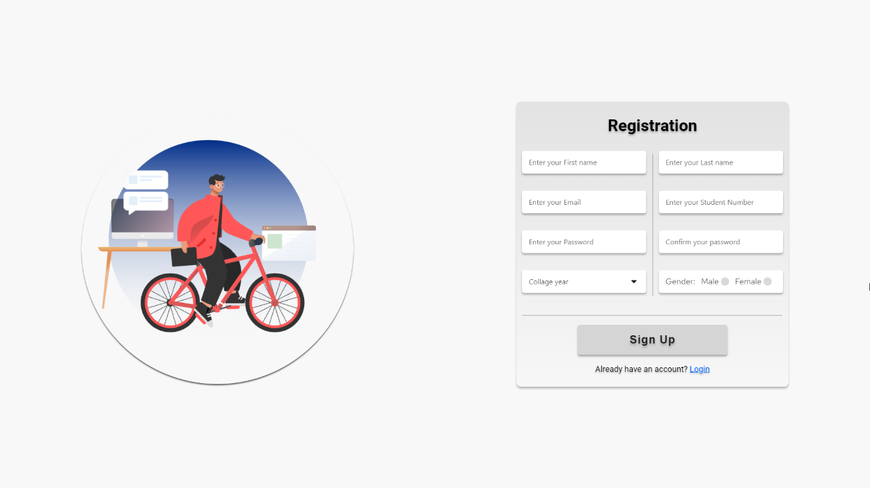

*Figure 5.2: Sign-Up page*

**Description**: Students must input their credentials on this page to create a Triibe account. The student must provide his or her first and last name, as well as an email address. Additionally, users must provide their student number and the password they choose to use for their account. The college year and gender, on the other hand, are optional. We have included a link that allows the student to return to the login page.

#### Home page

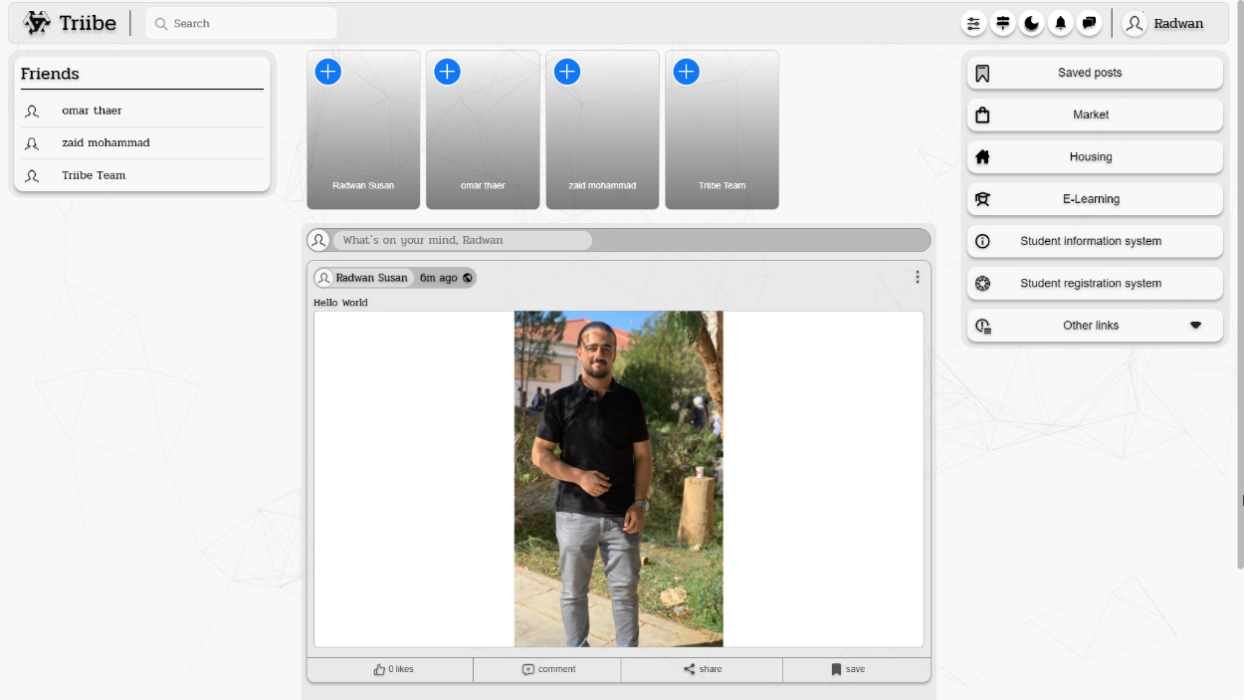

*Figure 5.3: Home page*

**Description**: This is the website's main page, from which students may access the majority of the website's features.

We'll break down the main page into smaller sections to make it easier to describe.

##### The Navbar



*Figure 5.4: The Navbar*

**Description**: The navbar will serve as the website's primary method of navigation, allowing students to go to different pages as well as use the search bar to find their friends, teachers, and colleges.

##### The friend’s sidebar

*Figure 5.5: The friend’s sidebar*

**Description**: This section allows students to see a list of their friends as well as access their profiles.

##### The right sidebar

*Figure 5.6: The right sidebar*

**Description**: The buttons in this sidebar will take you to some of the website's many useful pages. The Saved Posts will take you to a page where you can see all of the posts that the student has saved. A "market" button in the sidebar directs the student to a page where he or she can put products for sale that will be visible to the whole community. We also integrated a housing button, which directs the student to a website where he would browse and contact one of the numerous housing providers in the university's nearby areas. The last buttons include ones that will take you to the students' major sites within AHU.

##### The posts area

*Figure 5.7: The Main-content*

**Description**: The major content consists of stories and written posts, as well as posts that other users may interact with by leaving likes and comments, as well as sharing them and saving them.

##### Write post

*Figure 5.8: The Write post area*

**Description**: This box has a text field where the student will write the content of his or her entry. The box also has a variety of buttons with numerous functions, such as the input of a "photo or video" button, which adds media to the message. The "tag a friend" button creates a link that begins with "@" and ends with the name of the person. When this link is clicked, it brings the user to the friend's profile page. We also included the "Add Your Location" button, which inserts the student's location into the post, as well as the "GIF" button, which inserts a gif into the post. Finally, we've introduced a file button that allows users to upload files to the article.

##### Home page (Dark mode)

*Figure 5.9: The home page (dark mode)*

**Description**: For the website, we added a dark mode. Its design is shown in this figure. The "dark mode" button in the navbar will take you to dark mode.

#### Personal profile

*Figure 5.10: The personal profile page*

**Description**: This is the student's profile, which is visible to all users, to whom they can send a friend request. This page summarizes the primary contents and most of the postings that the user has made throughout his Triibe adventure. On this page, the user may also make a post. He has the option of uploading both his profile image and cover photo. This page also allows you to change the user's login credentials. Finally, we included a bio section where the user may write and express their thoughts as well as see basic information.

# OBSERVE AND EVALUATE

.

# CONCLUSION

## Conclusion

## Limitations

## Future Works

references

Staff, S. X. (2008, June 20). *University of Minnesota study uncovers the educational benefits of social networking sites*. Phys. Retrieved March 25, 2022, from <https://phys.org/news/2008-06-university-minnesota-uncovers-benefits-social.html>

Egot, E. (2017, December 13). *Statement of problem of social networking*. Academia. Retrieved March 26, 2022, from <https://www.academia.edu/35424022/statement_of_problem_of_social_networking>

Kaplan, A. M., & Haenlein, M. (2010). Users of the world, unite! The challenges and opportunities of social media. Business Horizons, 53, 59-68. <http://dx.doi.org/10.1016/j.bushor.2009.09.003>

Jess, J. I. T. (2012, August 12). *Facebook*. Jess-IT. Retrieved March 28, 2022, from <https://jinxizhou.wordpress.com/2012/08/12/facebook/>

Dutta, B. (2021, April 11). Waterfall Methodology: Working, Advantages & Disadvantages | Analytics Steps. Analyticssteps. Retrieved April 15, 2022, from <https://www.analyticssteps.com/blogs/waterfall-methodology-working-advantages-disadvantages>

ECTA Center: A Guide to the Implementation Process: Stages, Steps and Activities. (n.d.). Ectacenter. Retrieved May 8, 2022, from <https://ectacenter.org/implementprocess/interactive//>

jQuery AJAX Introduction. (n.d.). W3schools. Retrieved May 8, 2022, from <https://www.w3schools.com/jquery/jquery_ajax_intro.asp>

Johnson, Bruce. (2019). Visual Studio Code: End‐to‐End Editing and Debugging Tools for Web Developers. 10.1002/9781119588238.

Gibson, Simon (2011-04-28). "Diagramly: A Free Online Tool for Creating Diagrams and Charts". Gigaom. Retrieved 2021-11-12.

Cem Kaner (2006) Exploratory Testing, Florida Institute of Technology, Quality Assurance Institute Worldwide Annual Software Testing Conference, Orlando, FL, November 2006

Hardy, T. (2022, May 2). Is Your Website Design a Failure? 9 Reasons why they fail (And How to Save Yours). Sparx IT Solutions. Retrieved May 10, 2022, from <https://www.sparxitsolutions.com/blog/website-design/>

Brendensong, B. (n.d.). 5.4.3.The data validation process · brendensong/Google-Data-Analytics-Professional-Certificate Wiki. GitHub. Retrieved May 10, 2022, from <https://github.com/brendensong/Google-Data-Analytics-Professional-Certificate/wiki/5.4.3.The-data-validation-process>

1. Sample Appendix

<This is a sample Appendix. Insert additional appendices with the “Start New Appendix” command.>